Timothy Wooten
4-21-2015
Ebola Story

Season three, Episode of 10 of Breaking Bad featured dialogue about the Ebola virus. “Yeah, its a disease on the Discovery Channel where all your intestines sort of just slip right out of your butt,” Jesse Pinkman said.
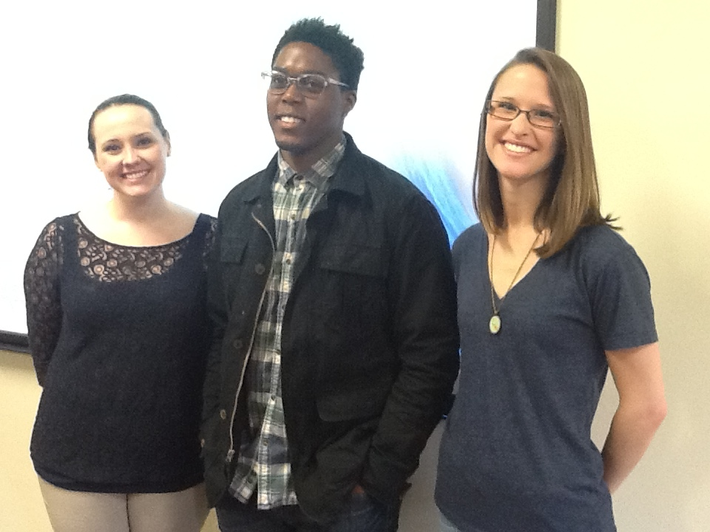
Laura Glasscock, A Winthrop associate professor of biology, and her Immunology 522 class,aimed to clarify some of the misconceptions people like Jesse Pinkman have about Ebola.
“ The virus was first identified in 1976,” said senior biology student Marquet Minor. The virus’s roots have been traced back to the Ebola River, in the Democratic Republic of Congo.
It was formally recognized after simultaneous outbreaks in the Sudan and Zaire. There have been less than 20 outbreaks since.
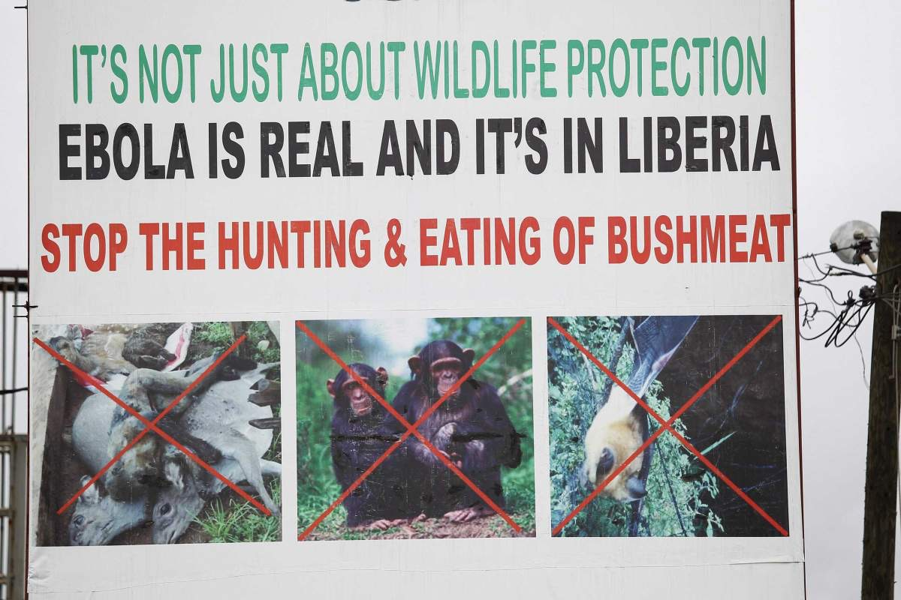
“There haven’t been many since then, and it has been contained to sub-Saharan Africa,” said senior biology major Grace Jones when talking about the frequency of Ebola outbreaks.
The virus is zoonotic in nature, meaning it can be transferred from animals to humans. For this reason Ebola can be contracted from the consumption of bush meat, fruit bats, monkeys and chimps. This has been a major problem in African countries, where these animals are main staples of the diet.
The 2014 outbreak was believed to be caused by a bat. A two-year-old was infected while playing by a hollow tree, which contained bats.
In addition,the virus may be spread through the direct contact to an infected person’s bodily fluids. Humans do not become contagious until symptoms have begun. The virus can live for hours on a dry surface, and for days if in room temperature bodily fluid.
A common worry is virus will become airborne or already is airborne. Diamond Melendez, one of Mrs.Glasscock’s senior immunology students, realized this concern after interviewing a group of students and non-scientists.
“I asked is it airborne yes or no? And a lot of people said yes. So I think it was very interesting that people don't know about this viral disease thinking its airborne when its not,” Melendez said.
It is very unlikely that the virus will mutate to become airborne, at least anytime soon. The virus is ancient in age, and is very stable. The mutation rate is so low in fact it would take 1,000 years to mutate to an airborne status.
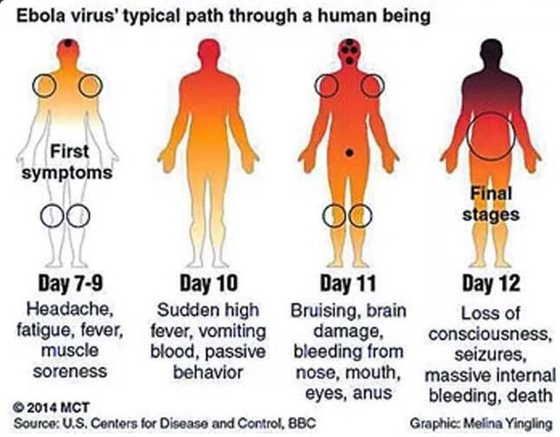
Ebola is a multifaceted virus; in fact there are five strains. Four of these strains are the Bundibugyo, Sudan, Reston and Tai Forest. The Zaire virus, the fifth strain, is what caused the most recent outbreak.Jones said this strain is “probably just the most likely to infect humans.”
Symptoms do not begin to appear until after the seventh day of infection. The symptoms that do emerge may seem similar to the common flu. By the 11th day the infected begin to bleed from their nose, mouth, eyes and anus. The final stages happen around day 12.
The virus first shuts down one’s immune system, then continues on to attack the vascular system. Once the vascular system is weakened Hemorrhagic fever sets in. Hemorrhagic fever is what causes the bleeding, vomiting, impaired kidney and liver function.
“Its very strategic. It breaks you down one wall at a time,” said Jones. Taylor Brown, a biology graduate student, added the virus is “nasty.”
The virus is not a surefire death sentence.The fatality rate has reached 70 percent, but that number could be higher than reported. It however does require the fastest treatment possible.
“The virus obviously moves very quickly through your body so if you can catch it before it starts breaking down your vascular system I think thats when you have the highest chance of helping it,” Brown said.
Containment of the virus has been difficult for several reasons.
Restricting people from leaving their homes is difficult, and especially when the outbreak is in a large area like Western Africa.
“You can’t just tell an individual to stay home if they’re sick because in these types of villages and things like that, people have to go out and get their food, they have to go to work,” Minor said.
People in infected areas tend to be distrusting of aid workers. “They don't really care for the red cross people, because they are taking away their loved ones, so a lot of people think this is a conspiracy,” Taylor Brown said.
A social reason for difficulty of prevention is burial practices. “They like to touch their dead, they’ll kiss their dead, and they’ll get in really close contact with these really infected people and once they’re infected the same things going to repeat,” said biology major Zachary Masters, also a member of Mrs. Glasscock’s class.
Scientists have discovered that the virus survives at least a week in the bodies of dead primates.
The removal of infected corpses has added to the mistrust within these communities. “They have been outraged involving the extraction of corpses, so different health-care providers they’ll come in and actually take the dead bodies, and send them off for cremation,” Minor said.
Officials also take some of the infected from their homes, and when these people die they are cremated. So people do not get the chance to properly say goodbye to their loved ones.
“These healthcare workers come into their towns and they’re scared, they’re afraid they know if they say hey I’m sick they might get taken away from their families,” Jones said. This can also skew the number of people who report their sickness.

Lack of education in these areas has made this process difficult to explain to these families. Healthcare officials have been meeting with village leaders, in attempts to get everyone on the same page.
The development of a vaccine has been a slow-moving process. Two drugs, Zmapp and TKM, are currently undergoing trials. These trials have raised ethical questions however.
“Most of these drugs are untested, so when you want to get a drug to be passed it needs to approved, so therefore clinical trials have to occur, during those clinical trials, you have to have a control group, so there is a group of patients, who are not going to actually be receiving the drug. So how do you determine who gets the drug and who doesn’t,” Minor said.
Another ethical concern is the media coverage of the Ebola virus. Jones recommends that news stations have “a biologist on staff.”
“Half the responsibility also falls on the media too because, I think you’re more inclined to write an exciting headline than a boring headline and so its just being true and having integrity,” Brown said.
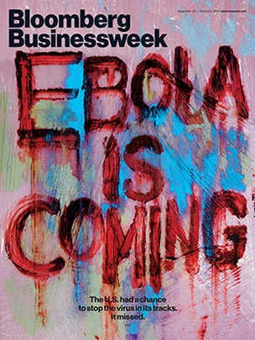
Minor believes the media confusion about Ebola comes down to the biological jargon. “They may read something and actually may not know what it means, they might do a quick Google search, and you know it can be just lack of education so there is confusion,” he said.
“The 2014 outbreak has slowed, but it is still important to take precautions. It has slowed down, but I think until its over you would have to take extreme precaution in dealing with it because it spreads very quickly,” Brown said.

